

***Deliverable 3***

***A Report on Prescriptive Analytics Scope for Apache Corporation***

Submitted by:

* **Walter Gutierrez**
* **Vivekanand Praturi**
* **Saurabh Dhoble**
* **Priyank Dsilva**

With Guidance from:

* **Donald R. Jones, Ph.D**

***June 19, 2016***

**Table of Contents**

1. **Company Summary 4**

1.1 About 4

1.2 Mission Statement 4

1.3 Values 5

1.4 Brief History 5

1.5 Recent Moves 6

1.6 Market Capitalization 7

* 1. Challenges 9

1. **Ideas for Prescriptive Analytics 9**

2.1 Applications of analytics to improve the performance

of Electrical Submersible Pumps (ESP). 10

1. **Prescription Model 13**

3.1 Variables 14

3.2 Models 15

3.3 Flowchart 19

1. **Visualizations 20**

4.1 Pump Expiration Date and Top Failure causes 20

4.2 Country, Field and Reservoir type analysis 21

4.3 Pump: Run life and Failure Cause Analysis and Prescriptions 22

4.4 List of Prescriptions for Failure Causes and Cost/Life Extension 23

4.5 Prescriptions in detail 24

1. **Annex 27**
2. **References 34**

**Table of Figures**

**Fig 1.1:** Investments by offshore and International Regions7

**Fig 1.2:** Market Capitalization (5years)8

**Fig 1.3:** Market Capitalization statistics (5years) 8

**Fig 1.4:** Forecast for Next Five Years8

**sssss**

**Fig 2.1.** Evolution of the price of oil. Reference price: WTI –

Cushing, Oklahoma (U.S. Energy Information Administration, 2016) 12

**Fig 3.1:** Flowchart 19

**Fig 4.1:** Histogram Displaying Estimated Pump Expiration time and Pie chart

with top 5 failure reasons.20

**Fig 4.2:** Pump Details with its Country, Field Type and Reservoir Type 21

**Fig 4.3:** Pump Details: Failure Cause and Prescriptions22

**Fig 4.4:** Accumulated cost of maintenance/repairing procedures25

**Fig 4.5:** Representation of the optimization problem26

**1. Company Summary**

1. **About**

Apache Corporation is one of the leading U.S. based independent crude oil and natural gas exploration and production companies. It is the second-largest independent oil and natural gas firm in the United States by market cap. In terms of the energy industry at large, it’s still a small player. It stands to be 18th largest oil company of the world.

Its appropriate size makes it flexible in its operations. Apache has made some recent investments in international and domestic deep water exploration. The company is undeniably one of the most conservative in the space, keeping its balance sheet clean and financing expansion with cash flow from operations, not debt. The firm grew over its 60-year history with safe investments in legacy assets from other oil companies. It is the leader in acquiring and exploitation operations related to oil and gas businesses, maximizing the potential from proven acquisition opportunities.

1. **Mission Statement**

Mission is to grow in an innovative, safe, environmentally responsible and profitable manner for the long-term benefit of our shareholders.

Ref:( <http://www.apachecorp.com/About_Apache/Mission.aspx> )

Mission statement stresses clearly on innovative approach to progress, which enunciates for their progress in past 60 years. Apache Corp also realizes that oil and gas industry involves use of natural resources and have made sure they keep their activities safe and be cautious about environment exploitation as well.

## **Values**

Throughout the 60 years in the oil and gas industry, Apache has built a team unified by their values, their commitment to building shareholder value and their culture, which empowers every employee to make decisions and achieve the company’s goals. The global team is brought together by a sense of ownership and the knowledge that best answers win.

Core values:

* Expect top performance and innovation;
* Seek relentless improvement in all facets;
* Drive to succeed with a sense of urgency;
* Safety is not negotiable and will not be compromised;
* Invest in our greatest asset: our people;
* Foster a contrarian spirit;
* Treat our stakeholders with respect and dignity;
* We derive benefit from the Earth and take our environmental responsibility seriously; and
* Conduct our business with honesty and integrity.

1. **Brief History**

Apache’s strategy is built on a portfolio of assets that provide opportunities to grow through both grassroots drilling and acquisition activities. Their goal is to build robust framework that supports sustainable, lower-risk, repeatable drilling opportunities, balanced by higher-risk, higher-reward exploration

Although other limitations, namely government price caps and regulation, battered its competitors, Apache remained profitable during the 1960s as the number of oil industry participants plummeted from 30,000 to 13,000. Besides its diversification into other businesses and its acquisition of several struggling competitors, Apache benefited from one of its most successful oil finds. In 1967 Apache drilled a well in the tiny town of Recluse, Wyoming, which immediately began delivering 50 barrels per hour. After drilling 11 more wells nearby, Apache was getting 2,800 barrels of oil each day from its Recluse operations. Analysts credited Apache’s skilled management team with allowing the company to successfully exploit a sudden strike of that magnitude. In July 1969 Apache Corporation’s shares were listed on the New York Stock Exchange.

1. **Recent Moves**

Company underwent several multi-billion dollar deals for new assets. The company merged in a $4 billion deal with Mariner Energy, purchased $11 billion in assets in a series of transactions from BP, Devon Energy, and Exxon Mobil, and struck a $3 billion deal with a long list of private equity players for Cordillera Energy Partners III LLC. Its recent acquisitions are focused in the United States. Management recently announced a plan to increase its total output by 34% in four years fueled by recent acreage acquisitions. By 2016, it will produce proportionately more oil and natural gas in the US, and less overseas.

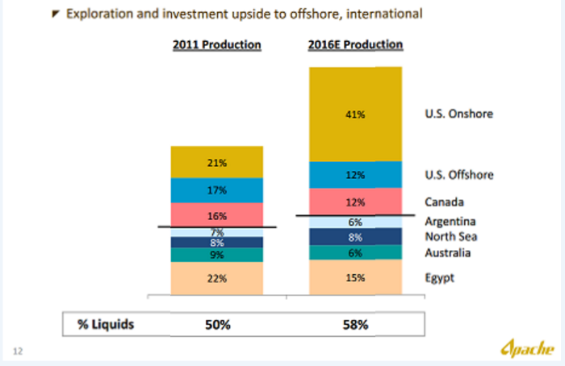

***Fig 1.1: Investments by offshore and International Regions***

Apache is very good at mobilizing assets for the best possible return. As other firms chased [natural gas acreage](http://thecollegeinvestor.com/12189/profit-from-global-growth-with-the-natural-resources-sector/) in the United States, Apache turned the other way, seeking acreage with less gas and more liquids – crude.

1. **Market Capitalization**

Market Capitalization (Market Cap) is a measurement of business value based on share price and number of shares outstanding. It generally represents the market's view of a company's stock value and is a determining factor in stock valuation.

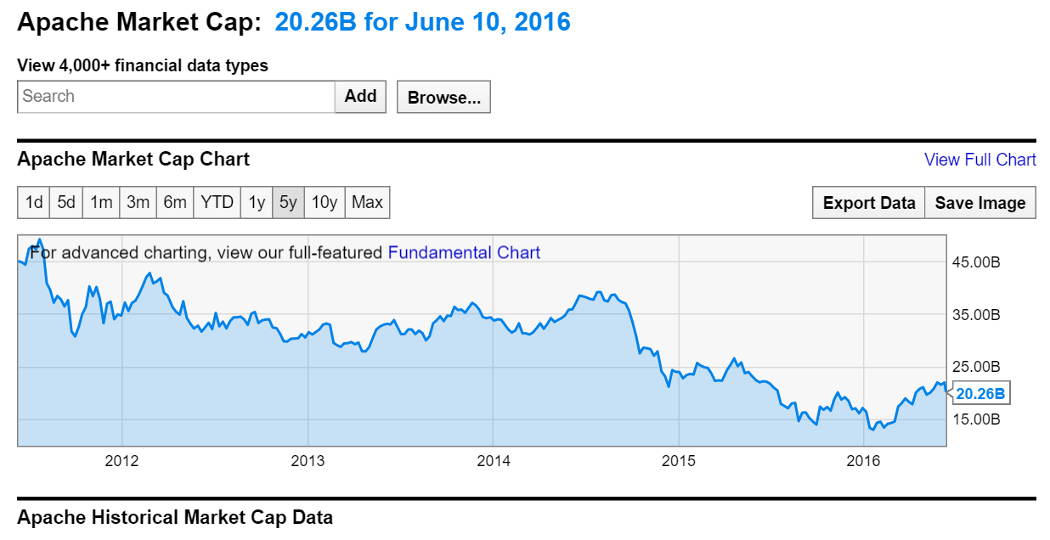

***Fig 1.2: Market Capitalization (5years)***

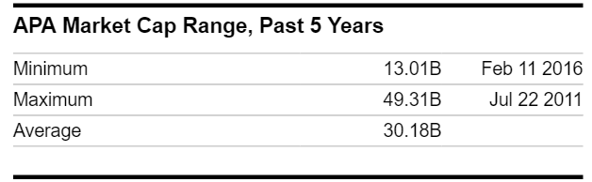

***Fig 1.3: Market Capitalization statistics (5years)***

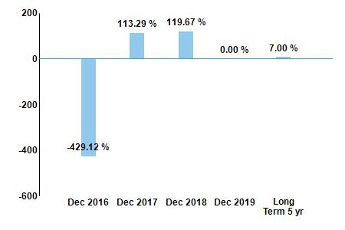

***Fig 1.4: Forecast for Next Five Years.***

Over the next five years, the analysts that follow this company are expecting it to grow earnings at an average annual rate of 7%. This year, analysts are forecasting earnings decrease of -429.12% over last year. Analysts expect earnings growth next year of 113.29% over this year's forecasted earnings.

1. **Challenges**

With new companies taking in market share, it requires unique strategies and planning to sustain in industry. Presently, it is challenged by concerns for its unimpressive capital allocation, technical capacity, and low confidence in the acreage quality outside the Permian Basin. The potential buyer, Exxon Mobil, may value this weakness.  It may also see substantial synergies in having a management team with Permian Basin experience and technical capabilities. The combination could shift Apache to the right path if it allocates capital more efficiently.

**2. Ideas for Prescriptive Analytics**

Huge amount of data can be captured at real time at lower costs and from previously inaccessible areas, to improve oilfield and plant performance. For example, real-time down-hole drilling data can be paired with production data of nearby wells to help adapt their drilling strategy, especially in unconventional fields.

**New well delivery**: The process of drilling and connecting a well, reducing lag time and minimizing the number of wells in process at a time can be significantly improved by leveraging Prescriptive analytics. For example, transmitting micro-seismic, 3D imaging over fiber-optic cables can improve new well delivery performance.

**Well and field optimization:** Collecting and analyzing massive volumes of geologic, operational and performance data from sensors connected via Internet of Things (IOT), each with many variables constantly changing, can help companies improve and optimize drilling parameters, well spacing and completions techniques, especially as they drill more wells and bring them online.

**Midstream:** Data analytics can help monitor pipelines and equipment and allow a more predictable and precise approach to maintenance and monitor. For example, sensors can indicate when equipment comes under unusual stress, allowing operators to perform preventive shutdowns or interventions that may avoid accidents or spills.

1. **Applications of analytics to improve the performance of Electrical Submersible Pumps (ESP).**

One topics in which the software company Ayata have been working with Apache Corporation (Ayata Prescriptive Analytics, 2013) is the application of prescriptive analytics to improve the efficiency of the Electrical Submersible Pumps (ESP) widely used in the oil industry (Wheatley, 2013).

A submersible pump is a device whose main feature is that it is installed submerged in the fluid to be pumped. It is composed of a hermetically sealed motor close-coupled to the pump body (Lyons, 1996). While jet pumps work by pulling fluids from the top of the well, ESP work by pushing the fluid to the surface. The main advantage of this concept is that it prevents pump cavitation, a problem associated with a high elevation difference between pump and the fluid surface. Submersibles are more efficient than jet pumps. Around 1928, Russian oil delivery system engineer and inventor Armais Arutunoff successfully installed the first submersible oil pump (ESP Pump, 2012).

Submersible pumps are widely used in oil production because they are able to operate across a broad range of flow rates and depths (Lyons, 1996). By decreasing the pressure at the bottom of the well, significantly more oil can be produced from the well when compared with natural production. ESP can be located on land or under the sea bed and they are able to pump oil to the surface at pressures of up to 5,000 pounds per square inch, from wells as deep as 12,000 feet.

According to General electric (GE), more than 130,000 ESPs operate around the world, generating 60 percent of the global oil production. Apache has more than 1,200 pumps operating on its wells globally, with about one-third of its overall oil production flowing through ESPs. According to Apache CTO Mike Bahorich (Presley, 2013), just a 1 percent improvement in global ESP performance would provide over a half-million additional barrels of oil per day given the amount of oil pumped through ESPs.

The evolution of oil price, seen in Fig 2.1, allows to forecast a price of oil around 50 dollars per barrel in the short term. With that figure, we can estimate that a single 1 percent improvement in global ESP performance would render Apache an extra $25 million-plus per day.

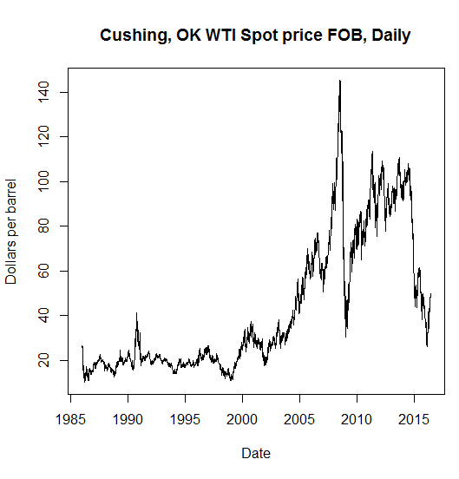

***Fig 2.1. Evolution of the price of oil. Reference price: WTI - Cushing, Oklahoma (U.S. Energy Information Administration, 2016).***

Predictive Analytics can help in the always difficult task of predicting the ESP’s service life. Many factors affect the useful life of the pumps, including the presence of corrosive elements in the fuel mix (such as Sulphur dioxide, water, etc.), the adverse conditions (high pressure and temperature), and the abrasion by sand and other solid particles. As each field and even each well has its own particularities, prediction of the pump yield or when a pump must be maintained or replaced is challenging. A first step to tackle the problem is the connection of the analytics systems to the Electrical Submersible Pump - Reliability Information and Failure Tracking System (ESP-RIFTS), a shared data repository by some of the world’s energy leaders (including Apache) that allows to get insight into the key factors that impact the ESP service life (C-FER Technologies, 2016). Participants benefit from a collection of tools, including: standardized data collection and qualification, analysis tools, project knowledge, reliability tools and forum discussions.

As Apache is already a participant in the ESP-RIFTS initiative, we need to take advantage of the information available on the repository to not only get insight, but to also proactively anticipate problems and prescribe solutions. By correlating field information, fluid information, and well information with failure information for particular combinations of surface equipment data, downhole equipment data, and operating and production data, we can anticipate when an equipment is about to fail and thus prescribe corrective actions. The list of parameters available for analytics is shown in the Annex.

**3. Prescription Model**

The statistical information from the oilfields around the word can be used to construct predictive models based on the correlations between the statistics of failures and the operation parameters. We defined two predictive models: the prediction of the Run Life of the EPS and the prediction of the probable Cause of Failure.

Predicting the Run Life of pumps and the possible Cause of Failure will help the company to preempt any failure and design automatic corrective actions and a smart maintenance/repair calendar. Being able to postpone failure and predict a time frame in which it can occur will save the company a huge amount of money in hasty and expensive corrective work.

1. **Variables**

The data set for the Prescription model will contain following variables:

* Start Date
* End Date
* Field Type
* Oil Density
* Reservoir Type
* Casing Diameter
* Sand condition
* CO2 condition
* H2S condition
* Emulsion

The independent variables:

* Field Type
* Oil Density
* Reservoir Type
* Casing Diameter
* Sand Condition
* CO2 Condition
* H2S condition
* Emulsion

The dependent variables:

* Run Life 🡪 End Date – Start Date
* Failure Cause

Type and Values of Variables:

* Country : String
* Field Type : Categorical (Offshore, Offshore (Subsea), etc.)
* Oil Density at STP : Real Valued
* Reservoir Type : Categorical (Consolidated Sandstone, etc.)
* Well Name : String
* Production Casing Outer Diameter: Real Valued
* Date Period Started : Date
* Date Period Ended : Date
* ESP System Failed : Binary
* Failure Cause : Categorical
* Sand : Ordinal (None, Present, Light, Moderate, Severe)
* CO2 : Ordinal (None, Present, Light, Moderate, Severe)
* H2S : Ordinal (None, Present, Light, Moderate, Severe)
* Emulsion : Ordinal (None, Present, Light, Moderate, Severe)

1. **Models**

Model 1: Run Life

*Regression model*:

The project foresee that the coefficients of the regression model will be updated with each modification of the data. The regression model calculated with a sample of 1000 measurements is shown below,

Where:

|  |  |
| --- | --- |
|  | Run life of the ESP (in ), from the start of its operation to its failure. |
|  | Binary variable set to “1” if the subscript coincides with the location of the oil field, “0” otherwise. |
|  | Density of the oil extracted (in ). |
|  | Binary variable set to “1” if the subscript coincides with the type of soil in which the reservoir is located, “0” otherwise. |
|  | Mean diameter of the well casing (in ) |
|  | Date of the start of ESP operation (in computer numeral). |
|  | Presence and severity of sand, in a scale from 0 (none) to 4 (severe) |
|  | Presence and severity of , in a scale from 0 (none) to 4 (severe) |
|  | Presence and severity of , in a scale from 0 (none) to 4 (severe) |
|  | Presence and severity of , in a scale from 0 (none) to 4 (severe) |

*Prescription*: prescribe a time frame in which failure can be anticipated based on the predictors.

Model 2: Failure Cause

*Regression model:*

*The coefficients values calculated with a sample of 1000 measurements are shown below,*

Where:

|  |  |  |  |  |  |  |  |  |  |  |  |  |  |  |  |  |  |  |  |  |  |  |  |  |  |  |  |  |  |  |  |  |  |  |  |  |  |  |  |
| --- | --- | --- | --- | --- | --- | --- | --- | --- | --- | --- | --- | --- | --- | --- | --- | --- | --- | --- | --- | --- | --- | --- | --- | --- | --- | --- | --- | --- | --- | --- | --- | --- | --- | --- | --- | --- | --- | --- | --- |
|  | A value indicating the predicted cause of failure. It is interpreted as follows,   |  |  | | --- | --- | |  | Sand (in/above pump) | |  | Reservoir failure | |  | Installation (control line) | |  | Manufacturing | |  | N/A | |  | Electrical (Packer Penetrator Failure) | |  | Sand (below pump) | |  | Electrical (main cable corrosion) | |  | Installation (field error) | |  | Operator error | |  | Electrical (design) | |  | Scale | |  | Third party | |  | Pre-emptive (fish) | |  | Electrical (VSD parameters) | |  | Installation (deviation) | |  | Installation (junk in well) | |  | Material selection | |  | Well integrity problem | |
|  | Binary variable set to “1” if the subscript coincides with the location of the oil field, “0” otherwise. |
|  | Density of the oil extracted (in ). |
|  | Binary variable set to “1” if the subscript coincides with the type of soil in which the reservoir is located, “0” otherwise. |
|  | Mean diameter of the well casing (in ) |
|  | Date of the start of ESP operation (in computer numeral). |
|  | Presence and severity of sand, in a scale from 0 (none) to 4 (severe) |
|  | Presence and severity of , in a scale from 0 (none) to 4 (severe) |
|  | Presence and severity of , in a scale from 0 (none) to 4 (severe) |
|  | Presence and severity of , in a scale from 0 (none) to 4 (severe) |

*Prescription:* This model allows to anticipate which are the most probable causes for the failure and to prescribe, for example, special contingency actions to deal with specific causes (such as sand problems).

Other predictive analytics methods can be used to determine the Run Life and the Failure Cause. We can implement this using a variety of models like Multiple Regression, Deep Learning, Ensemble methods to validate their efficiency in prediction.

1. **Flowchart**

The aforementioned predictive models can be used to preempt any EPS failure and design automatic corrective actions and a smart maintenance/repair calendar. Being able to postpone failures and predict a time frame in which they can occur will save the company sizeable amounts of money in hasty and expensive corrective work. The prescriptive flowchart is shown below.

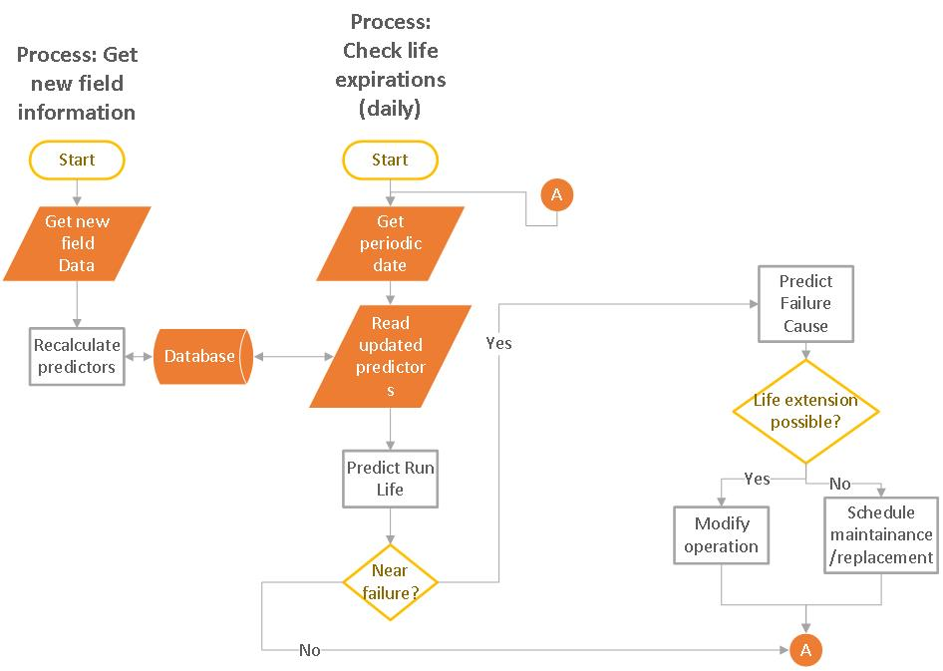

***Fig 3.1: Flowchart***

**4. Visualizations**

Data visualization is the presentation of data in a pictorial or graphical format. It enables decision makers to see analytics presented visually, so they can grasp difficult concepts or identify new patterns. Following section describe visualizations for prescriptions which could prove useful for Apache Corporation to make effective timely decisions.

**4.1 Pump Expiration Date and Top Failure causes**

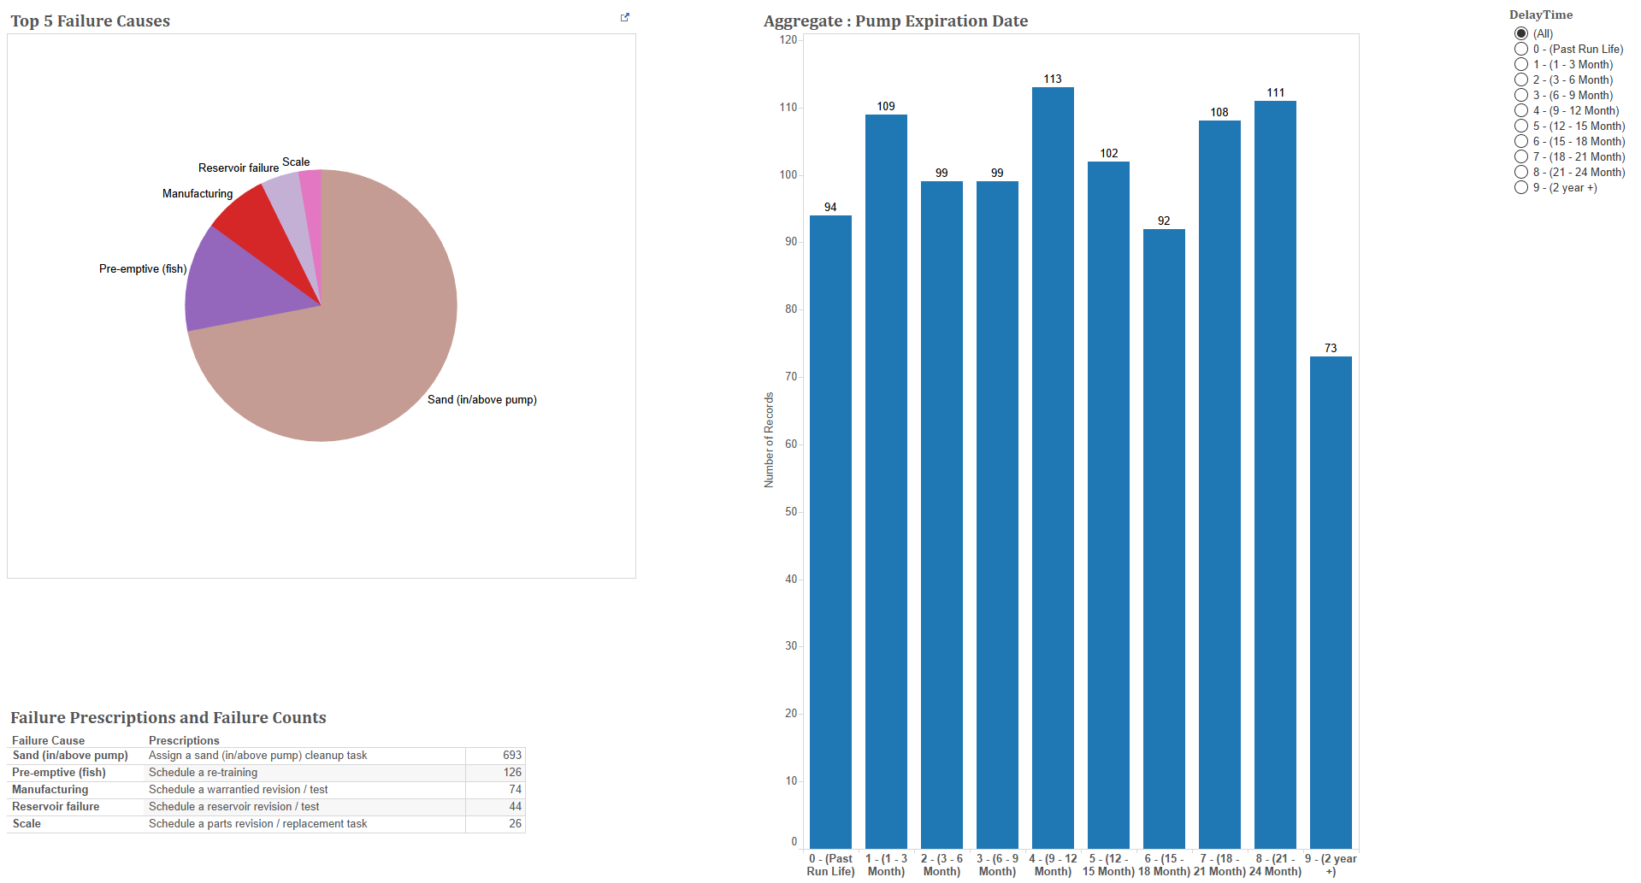

***Fig 4.1 Histogram Displaying Estimated Pump Expiration time and Pie chart with top 5 failure reasons.***

Above histogram provides a simple high-level overview of run life of pumps at Apache Corporation. For example, consider bar with making 109 at the top. It conveys information that there are 109 such pumps, which have their run life of 1-3 months. I.e., they may last for 1-3 months. This graph proves to be a health status check for pumps and plays important role in many crucial decisions such as resource allocation, cost allocation that can be decided based on its results. The pie chart shows the top 5 reasons of failure.

**4.2 Country, Field and Reservoir type analysis**

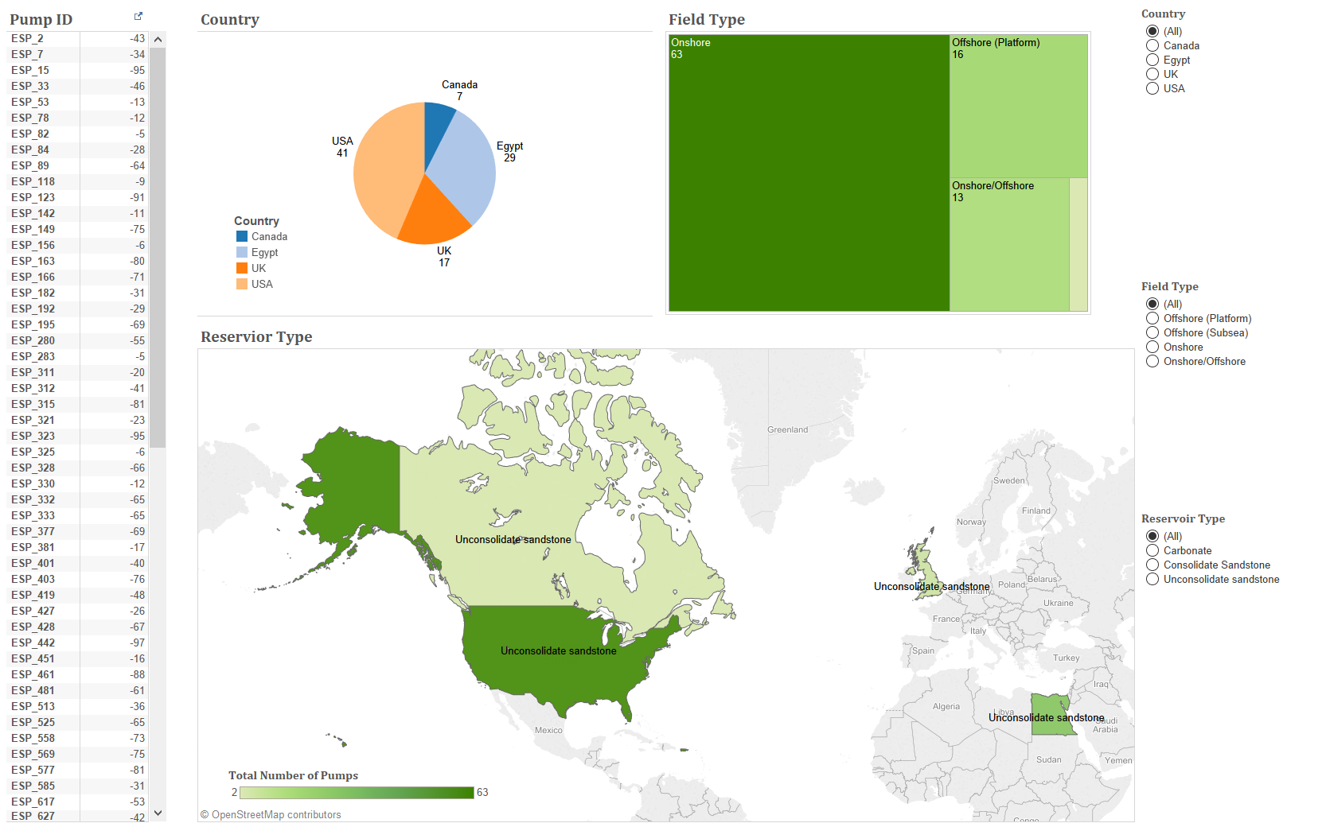

***Fig 4.2 Pump Details with its Country, Field Type and Reservoir Type***

Above visualization helps us have all pumps, which come under similar run life categorization from above histogram (Ref Fig 4.1). It displays pump IDs along with number of days remaining for failure to occur. These pumps are analyzed based on their location, i.e. their country, field type and reservoir type, as shown in above figure.

**4.3 Pump: Run life and Failure Cause Analysis and Prescriptions**

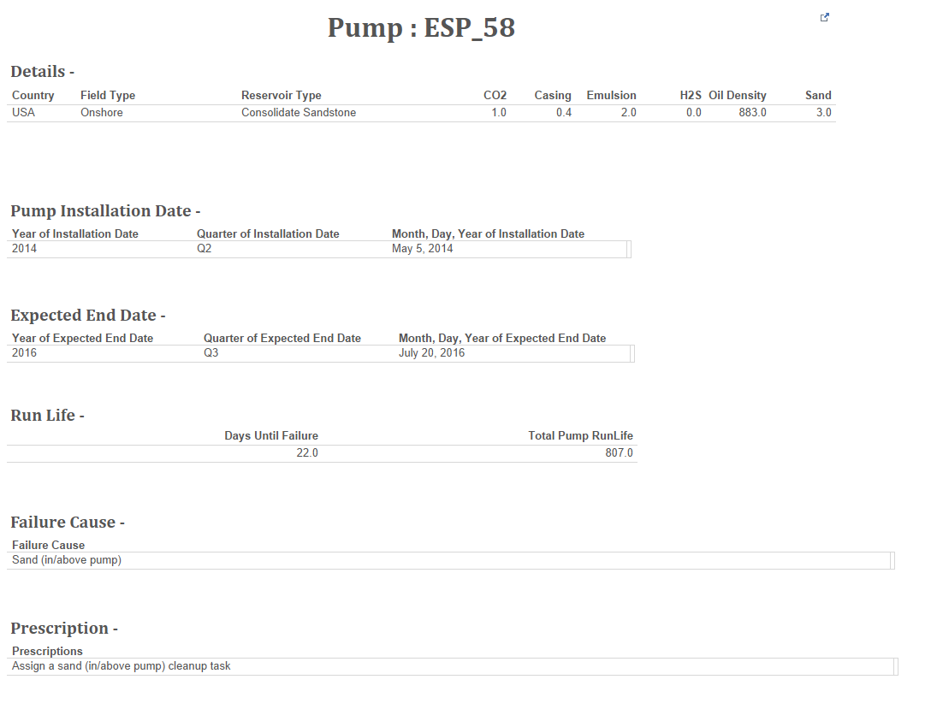

***Fig 4.3 Pump Details: Failure Cause and Prescriptions***

Business and Operations team both are equally curious to know the actual cause pumps for the failure. Above visualization provide a pump level detail results displaying all variable details used to determine run life of pumps, along with date of installation and time. It gives us a one-stop view of number of days remaining to failure and failure causes. Prescriptions sections provided knowledge of that needs to be done to fix the problem. This knowledge comes with various pump failure encounters of the past. These prescriptions help us identify and take appropriate actions.

**4.4 List of Prescriptions for Failure Causes and Cost/Life Extension**

The preliminary values of cost and life extension corresponding to each maintenance/repair procedure are shown in Table 1.

Table 1. Preliminary list of prescription procedures per failure cause, with associated cost and expected pump life extension.

|  |  |  |  |  |  |  |
| --- | --- | --- | --- | --- | --- | --- |
| ID | Failure Cause | Prescriptions | Cost (USD) | | Life extension (days) | |
| Workaround | Solution | Workaround | Solution |
| 1 | Third party | Schedule a third party revision / test | 2000 | 5000 | 200 | 500 |
| 2 | Reservoir failure | Schedule a reservoir revision / test | 20000 | 100000 | 2000 | 10000 |
| 3 | Unknown | Schedule a preventive maintenance task | 2000 | 5000 | 200 | 500 |
| 4 | Sand (in/above pump) | Assign a sand (in/above pump) cleanup task | 5000 | 12000 | 500 | 1200 |
| 5 | Sand (below pump) | Assign a sand (below pump) cleanup task | 10000 | 20000 | 1000 | 2000 |
| 6 | Installation (control line) | Schedule a follow-up revision / test | 2000 | 5000 | 200 | 500 |
| 7 | Scale | Schedule a parts revision / replacement task | 3000 | 9000 | 300 | 900 |
| 8 | Manufacturing | Schedule an OEM revision / test | 2000 | 3000 | 200 | 300 |
| 9 | Electrical (design) | Schedule an electrical revision / maintenance task | 6000 | 12000 | 600 | 1200 |
| 10 | Electrical (main cable corrosion) | Schedule an electrical revision / maintenance task | 6000 | 12000 | 600 | 1200 |
| 11 | Installation (deviation) | Schedule a follow-up revision / test | 2000 | 3000 | 200 | 300 |
| 12 | Installation (junk in well) | Schedule a follow-up revision / test | 2000 | 3000 | 200 | 300 |
| 13 | Material selection | Schedule an OEM revision / test | 2000 | 3000 | 200 | 300 |
| 14 | Installation (field error) | Schedule a follow-up revision / test | 2000 | 3000 | 200 | 300 |
| 15 | Electrical (Packer Penetrator Failure) | Schedule an electrical revision / maintenance | 6000 | 12000 | 600 | 1200 |
| 16 | Pre-emptive (fish) | Schedule a re-training | 4000 | 9000 | 400 | 900 |
| 17 | Well integrity problem | Schedule a well revision / maintenance | 20000 | 100000 | 2000 | 10000 |
| 18 | Operator error | Schedule a re-training | 4000 | 9000 | 400 | 900 |
| 19 | Electrical (VSD parameters) | Schedule an electrical revision / maintenance | 6000 | 12000 | 600 | 1200 |

**4.5 Prescriptions in detail**

Let’s suppose the operator receive an alert in his/her dashboard indicating that a type of failure is possible shortly, given the statistic. The system knows that for each type of failure there are two preemptive procedures defined:

* A workaround, probably performed by in-house workforce.
* A permanent solution, probably performed by more specialized (and more expensive) resources from other company.

The task is to select the correct procedure, automatically if possible.

Each oil well has, by design, a life expectancy. The figure is very variable, but we can simplify and take an average of 20 years (7300 days)

The expected life of the pump is shorter, but we can extend its life by performing maintaining/repairing procedures or simply replacing the pump. Therefore, we can expect that a number of procedures will be performed from the current date to the end of the oil well life. Each procedure can be either a workaround or a permanent solution. Permanent procedures will usually cost more than workarounds, but will result in a larger extension of the pump life. The goal is to select the immediate procedure.

This is exemplified in the Figure 4.4 which shows the accumulated costs of repairing/maintaining procedures with time (units are arbitrary). The final time represents the end of the life of the oil well and the initial time represents the time in which an alert appeared in the dashboard indicating the probability of a near failure of the pump. Ideally, the pump life can be extended several times. The red line represents life extensions if only workarounds were to be used, while the blue line shows life extensions if only permanent solutions were to be performed. Each workaround has a cost and extends pump life by . On the other hand, each permanent solution has a cost and extends pump life by .

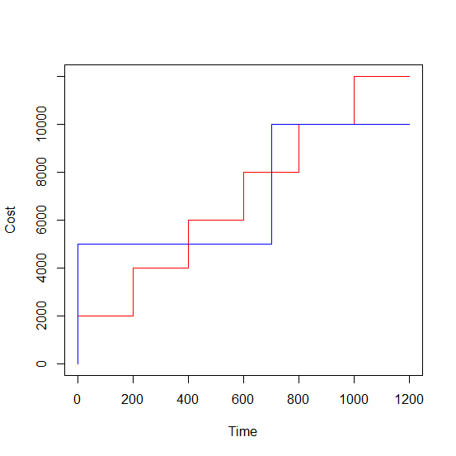

***Fig 4.4 Accumulated cost of maintenance/repairing procedures. The red line represents life extensions if only workarounds were used. The blue line shows life extensions if only permanent solutions were used.***

The function to minimize (objective function) is the total cost :

The variables to calculate are:

: The number of workarounds until the end of the oil well life.

: The number of permanent solutions until the end of the oil well life.

The constraints are as follows,

Where:

: The expected extension of the pump life due to the workaround.

: The expected extension of the pump life due to the permanent solution.

The immediate procedure can be selected according to the result of the linear programming solution, as follows,

* If then implement automatically the workaround.
* If then implement automatically the permanent solution.
* Otherwise, instruct the operator to make a manual decision.

In the example previously shown in Fig 4.5, a calculation with the linear programming gives the following results,

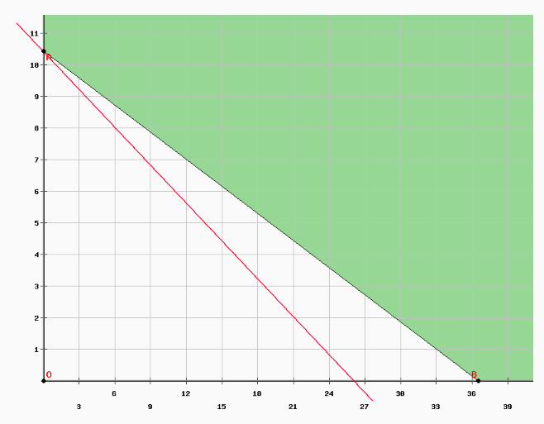

**Fig 4.5 Representation of the optimization problem.**

Because , the system is able to automatically activate the permanent solution.

**5. Annex**

**Data fields available in the ESP-RIFTS repository**

|  | **Parameter** | **Description** |
| --- | --- | --- |
| Field Information | Division Name | Name of operating unit, group of field, etc. |
| Field Name | Name of oil field |
| Pad or Platform Name | Name of group of wells |
| Field Location (Country) | Name of country field is in |
| Location of ESP Supply Centre | Country, Province/State, nearest Town/City of source of ESP system. If more than one supply centre, please provide location of main supply centre. |
| Location of ESP Teardown Facility | Country, Province/State and nearest Town or City where pulled ESPs are sent for teardown and inspection. If more than one teardown facility, please provide location of main teardown facility. |
| Field Type | Onshore, Offshore (Platform), Offshore (Subsea), Onshore/Offshore |
| Fluid Information | Oil Density at STP | Oil density in°API at standard temperature (15°C) and pressure (1 atm) |
| Reservoir Temperature | Fluid temperature at reservoir conditions |
| Oil Bubble Point Pressure | Bubble point (vapour) pressure of oil at Reservoir Temperature |
| Dead Oil Viscosity at STP | Dead oil viscosity at standard temperature (15°C) and pressure (1 atm) |
| Live Oil Viscosity at Reservoir Conditions | Live oil viscosity at reservoir temperature and pressure. If not provided, Live Oil Viscosity at Reservoir Conditions will be calculated as per Notes. |
| Well Information | Well Name | Name or identifier of well |
| Well Type (Geometry) | Vertical, Slant, Deviated, Horizontal, Sidetracked, or Multilateral |
| Wellhead Location | Onshore, Platform, Subsea |
| Reservoir/Zone Name | Name(s) of producing reservoirs (during production period) |
| Reservoir Type | Carbonate, Consolidated Sandstone, Unconsolidated Sandstone, Evaporate |
| Reservoir Recovery Mechanism | Aquifer drive, Solution Gas Drive, Water flood, EOR (e.g., C02 flood, Water-Alternating-Gas (WAG), Polymer Flood) |
| Completion Type | Perforated Casing, Open hole, or Slotted liner |
| Sand Control Type | Type of sand control installed in the well during the production period, e.g. Gravel Pack, Slotted Liner, Wire-wrapped Screen, etc. If no sand control installed, please indicate None. |
| Production Casing Outer Diameter | Nominal outer diameter of the production casing |
| Runtime Data (dates) | Production Period Number | Production period number for well |
| Date Installed | Date ESP system was installed |
| Date Period Started | Date ESP system was first started. If not provided, the Date Period Started will be assumed equal to the Date Installed. |
| Period Status | Completed or Still Running |
| Date Period Ended | Date ESP system failed, was shutdown, or last date record was updated if ESP still running. If not provided, the Date Period Ended will be assumed equal to the Date Pulled. |
| Date Pulled | Date ESP system was pulled |
| Actual Runtime | Days the ESP system was actually running. If not provided, Actual Runtime will be assumed equal to Duration |
| Failure Information (as per ESP Failure Nomenclature Standard) | ESP System Failed? | Did/has the ESP system failed (Yes or No)? This parameter should be consistent with the Period Status, i.e. if Period Status is "Still Running", then ESP System Failed? should be "No". |
| Reason for Pull: General | The motive for the ESP System pull |
| Reason for Pull: Specific | The specific motive for the ESP System pull |
| Primary Failed Item | The primary failed ESP component/system (after investigation) |
| Primary Failure Descriptor | The primary descriptor of the failed ESP component/system (after investigation) |
| Secondary Failure Descriptor | The secondary descriptor of the failed ESP component/system (after investigation) |
| Failure Cause: General | Cause Category: Circumstances during design, manufacture or use that led to the failure (after investigation) |
| Failure Cause: Specific | Specific cause: Circumstances during design, manufacture or use that led to the failure (after investigation) |
| Failure Comments | Specific notes regarding the failure. Include a description of the contaminant if the Contaminated failure descriptor is used. |
| Surface Equipment Data | Control Panel Type | Type of control panel: Switch board, Soft start, Variable Frequency/Speed Drive |
| Control Panel Vendor | Name of vendor/manufacturer of control panel component(s) |
| Power Source | Local Power Line/Grid, Field Generator, Wellsite Generator |
| Power Quality | Excellent, Good, Average, Low, Poor |
| Downhole Equipment Data | Pump Vendor | Name of vendor/manufacturer of pump component(s) |
| Pump Type/Model | Catalogue type/model of pump (e.g., DN3000) |
| Number of Pump Stages | Number of pump stages |
| Pump Trim | Metallurgy, elastomers and/or coatings |
| Pump Serial Number(s) | Serial number(s) or unique identifiers for that specific pump |
| Pump New/Used | When installed, was the pump New, Used (without service or minor servicing only), or Repaired (used and serviced) |
| Pump Pull Condition | Is the pump Reusable or Not Reusable in the intended application in its current state? |
| Seal Vendor | Name of vendor/manufacturer of seal (protector) component(s) |
| Seal Type/Model | Catalogue type/model of seal (e.g., LSBSB-HL) |
| Seal Trim | Metallurgy, elastomers and/or coatings |
| Seal Serial Number(s) | Serial number(s) or unique identifiers for that specific seal |
| Seal New/Used | When installed, was the seal New, Used (without service or minor servicing only), or Repaired (used and serviced) |
| Seal Pull Condition | Is the seal Reusable or Not Reusable in the intended application in its current state? |
| Motor Vendor | Name of vendor/manufacturer of motor component(s) |
| Motor Type/Model | Catalogue type/model of motor (e.g., KMH) |
| Motor Rated Power @ 60Hz | Rated power of the motor at 60 Hz |
| Motor Trim | Metallurgy, elastomers and/or coatings |
| Motor Serial Number(s) | Serial number(s) or unique identifiers for that specific motor |
| Motor New/Used | When installed, was the motor New, Used (without service or minor servicing only), or Repaired (used and serviced) |
| Motor Pull Condition | Is the motor Reusable or Not Reusable in the intended application in its current state? |
| Pump Intake Vendor | Name of vendor/manufacturer of pump intake component(s) |
| Pump Intake Type | Type of pump intake: Standard Bolt-on Intake, Static Gas Seperator, Rotary Gas Seperator, or Gas Handler |
| Pump Intake Trim | Metallurgy, elastomers and/or coatings |
| Pump Intake Serial Number(s) | Serial number(s) or unique identifiers for that specific pump intake |
| Pump Intake New/Used | When installed, was the pump intake New, Used (without service or minor servicing only), or Repaired (used and serviced) |
| Pump Intake Pull Condition | Is the pump intake Reusable or Not Reusable in the intended application in its current state? Cable Vendor Name |
| Cable Vendor | Name of vendor/manufacturer of cable component(s) |
| Cable AWG Size | American Wire Gauge (AWG) size of the cable |
| Cable Type/Model | Catalogue type/model of cable (e.g., Redalead or CELF) |
| Cable Armour | Galvanized, Monel, Stainless Steel, etc. |
| Cable Serial Number(s) | Serial number(s) or unique identifiers for that specific cable |
| MLE Type/Model | Catalogue type/model of motor lead extension (e.g., KELB) |
| Cable New/Used | When installed, was the cable New, Used (without service or minor servicing only), or Repaired (used and serviced) |
| Cable Pull Condition | Is the main power cable Reusable or Not Reusable in the intended application in its current state? |
| Wellhead Penetrator Type/Model | Catalogue type/model of wellhead penetrator |
| Packer Penetrator Type/Model | Catalogue type/model of packer penetrator |
| DH Monitoring System Vendor | Name of vendor/manufacturer of downhole monitoring system |
| DH Monitoring System New/Used | When installed, was the downhole monitoring system New, Used (without service or minor servicing only), or Repaired (used and serviced) |
| DH Monitoring System Pull Condition | Is the downhole monitoring system Reusable or Not Reusable in the intended application in its current state? |
| Shroud Installed? | Was a shroud installed on the system? |
| Shroud Casing Outer Diameter | Outer diameter of shroud. If a shroud is not installed, then leave <blank>. |
| Tubing Outer Diameter | Nominal outer diameter of production tubing |
| Packer Installed? | Was a packer installed with the ESP System? |
| Packer Depth | Measured depth to the top of the packer. If a packer is not installed, then leave <blank>. |
| Y-Tool Installed? | Was a Y-Tool installed with the ESP System? |
| Pump Seating Depth MD | Measured depth of the pump intake |
| Pump Seating Depth TVD | Vertical depth of the pump intake |
| Inclination at PSD | Inclination (hole angle) at the PSD |
| Maximum Dogleg | Maximum curvature that the ESP had to pass through during installation |
| Number ESP Systems in Well | Number of complete ESP Systems (motor-seal-intake-pump) installed in the well |
| ESP System Configuration (Single/Parallel/Series) | If there were/are more than one ESP Systems installed, where they installed in parallel or in series? |
| ESP Deployment Method | Method used to install/deploy the ESP: Tbg, Coiled Tbg, Cable, or Wireline. |
| First ESP System Installed in Well? | Was/is this ESP installation the first ESP installed in this well? (Yes/No) |
| Equipment Comments |  |
| Operating and Production Data | Total Flow Rate | Total flow rate of produced liquids at standard conditions |
| Water Cut | Water flow rate by %volume of produced liquids. Alternatively, produced oil and water rates may be provided. |
| Pump Intake Pressure (PIP) | Producing pressure at the pump intake. If not provided, Pump Intake Pressure will be calculated as per Notes. |
| Producing Fluid Level | Measured depth to top of annular fluid level |
| Pump Intake Temperature | Producing fluid temperature at the pump intake. If not provided, Pump Intake Temperature will be assumed equal to the Reservoir Temperature. |
| Free Gas at Pump Intake | Free gas at the pump intake (% by volume at pump intake pressure and temperature). If not provided, Free Gas at Pump Intake will be calculated as per Notes. |
| Wellhead Pressure | Pressure of produced fluids at the wellhead |
| Casing Head Pressure | Pressure in the casing annulus at the wellhead |
| Reservoir Static Pressure (Latest) | Static or shut-in pressure at the pump intake |
| Gas-Oil Ratio (GOR) | Producing gas-oil ratio. Alternatively, produced gas rate at standard conditions may be provided. |
| Sand Cut | Concentration of produced sand by %volume of produced liquids and solids. If no sand was produced, please enter zero. Alternatively, produced sand rate may be provided. |
| Scale? | Presence and relative severity of scale: None, Yes-Present, Light, Moderate, or Severe |
| Asphaltenes? | Presence and relative severity of asphaltenes: None, Yes-Present, Light, Moderate, or Severe |
| Solids? | Presence and severity of all solids, including sand: None, Yes-Present, Light, Moderate, or Severe |
| Sand? | Presence and severity of sand: None, Yes-Present, Light, Moderate, or Severe |
| Corrosion? | Presence and severity of Corrosion: None, Yes-Present, Light, Moderate, or Severe |
| CO2 (% by volume) | Concentration of CO2 (preference by %volume of gas). If no CO2 observed, enter zero. |
| H2S (% by volume) | Concentration of H2S (preference by %volume of gas). If no H2S observed, enter zero. |
| CO2? | Presence and relative severity of CO2: None, Yes-Present, Light, Moderate, or Severe3. |
| H2S? | Presence and relative severity of H2S: None, Yes-Present, Light, Moderate, or Severe3. |
| Water pH | Acidity of produced water - tends to be indication of corrosivity |
| Water Salinity (Cl- ppm) | Chloride concentration - indication of water density and corrosivity |
| Emulsion? | Presence and relative severity of emulsion problem: None, Yes-Present, Light, Moderate, or Severe |
| Motor Frequency | Average frequency (Hz) of power supply to motor |
| Motor Voltage | Average voltage of power supply to motor |
| Motor Current | Average current of power supply to motor |
| Number of Restarts During Period | Total number of starts during the production period |
| Surface Steam Injection Pressure | Pressure of the injected steam at the surface |
| Casing Vent Gas Pressure | Pressure of gas at the casing vent |
| Casing Vent Gas Rate | Gas flow rate at the casing vent |
| Stage of the SAGD Cycle | SAGD Cycle stage at time of Production Data measurement: Circulation, SAGD, or Blowdown |
| Period Comments | Corrosion treatments, etc. |
| Practices | Any written or verbal procedure, practices associated with design, procurement, manufacture, transportation, inspection, installation, operating, pulling and/or failure analysis |  |
| ESP Surveillance System (SCADA/Operator/Other) |  |
| Automatic or Manual Control? |  |

Project R Code: 

Project Data Source:

Project Viz Source:

**6. References**

* Ayata Prescriptive Analytics. (2013, Septiembre 5). *Customer Profile: Apache Corporation.* Retrieved from Ayata Prescriptive Analytics: http://ayata.com/customer-profile-apache-corporation/
* C-FER Technologies. (2016, May 6). Retrieved from Electrical Submersible Pump - Reliability Information and Failure Tracking System (ESP-RIFTS): http://jip.esprifts.com/
* *ESP Pump*. (2012). Retrieved from ESP Pump: http://esppump.com/
* Holdaway, K. (2014). *Harness Oil and Gas Big Data with Analytics: Optimize Exploration and Production with Data Driven Models.* Cary, North Carolina, USA: John Wiley & Sons.
* Lyons, W. C. (1996). *Standard handbook of petroleum & natural gas engineering* (Vol. 1). Gulf Professional Publishing.
* Presley, J. (2013, July 1). ESP for ESPs? *Hart E&P Magazine*. Retrieved from http://www.epmag.com/esp-esps-696411#p=full
* U.S. Energy Information Administration. (2016, June 6). *Spot prices.* Retrieved from Petroleum & Other Liquids: https://www.eia.gov/dnav/pet/pet_pri_spt_s1_d.htm
* Wheatley, M. (2013, May 29). Underground Analytics: The Value in Predicting When an Oil Pump Fails. *DataInformed Magazine*. Retrieved from http://data-informed.com/underground-analytics-the-value-in-predicting-when-an-oil-pump-fails
* Ycharts : <https://ycharts.com/companies/APA/market_cap>
* Nasdaq : <http://www.nasdaq.com/symbol/apa/earnings-growth#/ixzz4BJr3lMui>
* Izquierdo Granja, D., & Ruiz Ruiz, J. J. (n.d.). *PHPSimplex*. Retrieved from PHPSimplex: http://www.phpsimplex.com/en/#